John’s Boys, BCS
Grant Program Guidelines
John’s Boys BCS, Inc. is a local non-profit organization dedicated to providing assistance, resources, and support to the foster community of the Brazos Valley. Our programs are designed to promote awareness and advocacy for foster children by providing personal and comfort essentials during times of transition, increasing access to child care training to ease the strain on the family unit, and community inclusion through grant programs providing access to extracurricular activities as well as funding for displaced children and youth.
The Kinship Cares Grant is to provide additional support for children involved in a kinship placement who do not receive the same recognition or resources as children placed in traditional foster care and whose families are frequently burdened with the need to purchase daily living needs and additional furniture for one or more children unexpectedly. These grants are $250 and must be used to promote the health and wellness of a child in a kinship placement.
The Stepping Stone Grant recognizes the needs of young adults age 17-23 who are transitioning out of foster care or kinship placements or other substantial displacement and are lacking traditional support as they begin the next stage of life. These grants are $250 and are to be used for shelter, food, transportation, or job and school related expenses.
The Sports, Technology, Arts, Recreation, & Skills Program (STARS), will promote community inclusion by increasing access to extracurricular programs throughout the Brazos Valley for children in foster care. We hope to be able to launch this program in 2021 and are currently working to negotiate lower tuition and dues across 6 categories of extracurricular activities. Additionally, we are applying for community, state, and federal grants which would allow foster parents to apply for scholarship funds to further reduce costs associated with participation in these activities for children who would otherwise have no access, further marginalizing these at-risk youth. These are need based scholarships which are capped at $250 per year.
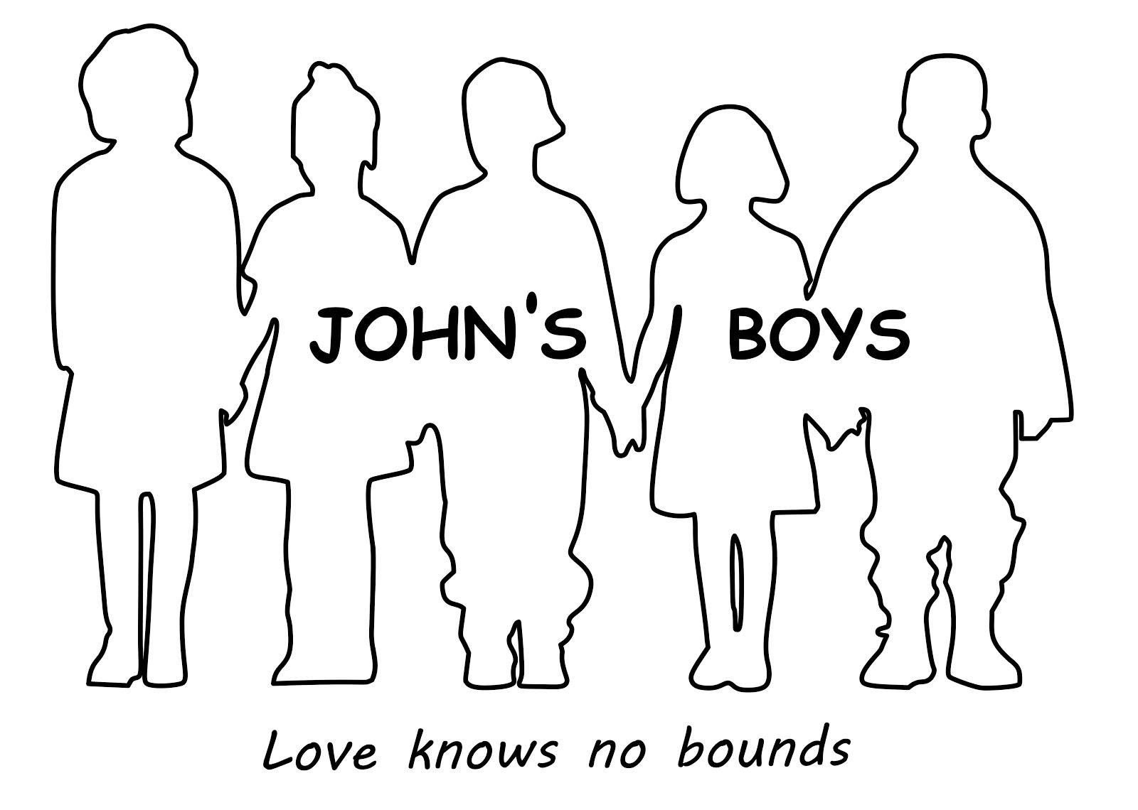

Criteria and eligibility (Kinship Cares Grant)
- Applicant must currently have a child in their home as a kinship placement.
- Applicant must complete a short 1 page written or typed essay on your kinship placement experience detailing the need for support.
- Include a copy of a valid government ID.
- Applicant may not be related to any Board of Directors or committee members as this presents a conflict of interest.
Criteria and eligibility (Stepping Stone Grant)
- Applicant must be between ages 17-23.
- Applicant must complete a short 1 page written or typed essay discussing your educational and professional goals and objectives.
- Must have been in foster care, kinship placement, or experienced significant displacement (abandonment, homelessness, etc.) within the last 3 years.
- Include a copy of a valid government ID.
- Applicant may not be related to any Board of Directors or committee members as this presents a conflict of interest.
Criteria and eligibility (STARS Grant)
- Applicant must be the parent of a foster child or kinship placement.
- Applicant must be able to detail the expenses of the extracurricular program being requested.
- Applicant must complete a short 1 page written or typed essay on your foster placement experience including the child’s desire and interest in the extracurricular activity for which funding is being requested.
- Include a copy of a valid government ID.
- Applicant may not be related to any Board of Directors or committee members as this presents a conflict of interest.

General Instructions
- DEADLINE for Fall scholarship applications is July 15, 2020, 5:00 p.m. (NO exceptions).
- Refer to application process below for a list of the supporting documents needed. Incomplete applications will not be considered.
- Must reside in the Brazos Valley (Brazos, Leon, Robertson, Burleson, Grimes, Madison, and Washington Counties)
- All applicants who are awarded grants will be required to submit receipts for use of funds. Failure to do so could rendure applicant ineligible for any future John’s Boys grants.
- If any question does not apply to you in this application please put N/A in the space.
- Type or print legibly. Illegible applications will not be considered. You may also download a copy of the application online at www.johnsboys.com/
- You will be notified by email or post mail by August 1st regarding the status of your application.
- If you have more than one foster child or kinship placement in your home please complete one application and include all children’s demographics (age and name).
- If you have any questions about the application, please email johnsboys2019@gmail.com
Application Process
- Applicant must submit the following items:
- Completed application form (if handwritten, please print legibly).
- Demonstration of need (when required).
- Personal Essay. Essay must be at least 1 legibly written or typed page, double-spaced, 12 pt / Times New Roman font.
- Valid government photo ID.
- Valid contact information: Phone number, mailing address, email

Deadline for the Fall application is July 15, 5:00 p.m. Applications postmarked after this date will not be considered.
Please mail completed application to:
John’s Boys BCS
ATTN: Scholarship Committee
4101 Downton Abbey
College Station, TX 77845
Or email to:
johnsboys2019@gmail.com

John’s Boys BCS  Grant Program Application Fall 2020 |  |  | Grant you are applying for:  ___STARS Grant  ___ Kinship Cares Grant  ___ Stepping Stone Grant
 |  |  | Application Date:
Please type or print your answers. If application is illegible it will be returned to you.

SECTION 1: GENERAL INFORMATION
1. | Last Name: | First Name:
2. | Mailing Address  Street:___________________________________  City:__________________________ State:_____ ZIP:___________
3. | Daytime Phone: ( ) ______-________
4. | Date of Birth (mmddyyyy): ____________
5. | What agency was your most recent placement through? _________________________
SECTION 2: STARS GRANT APPLICANTS
6. | Name of child/ren:______________________________ |  |  | Age/s: ________
7. | What agency is the child placed through? ________________________________
8. | What extracurricular activity are you requesting the STARS grant for? ______________________  Include additional Information in Section 5. (team/club, address, instructor, website, etc):
9. | What are the specific expenses for this activity (dues, equipment, competition travel, etc.)?
SECTION 3: KINSHIP CARES GRANT APPLICANTS
10. | Name of Child/ren: _____________________________ Age/s:____________
11. | Placing agency: ________________________________
12. | List any requirements you were asked to meet in order to accept your kinship placement:
SECTION 4: STEPPING STONE GRANT APPLICANTS
13. | What was your most recent foster/kinship placement? (agency, address, situation, etc.)  Years:_________
14. | Highest level of school completed? ____________________
15. | Current employer:___________________________  Hire date: _______________  Position:_________________ Full Time or Part Time:______________  **if your employment was affected by COVID-19, provide most recent information and detail below in the comments section.
16. | List your academic honors, community involvement, extracurricular activities:
SECTION 5: COMMENTS AND ADDITIONAL INFORMATION
17. | Comments:

STATEMENT OF ACCURACY

I hereby affirm that all the above stated information provided by me is true and correct to the best of my knowledge. I also consent that my picture may be taken and used for any purpose deemed necessary to promote John’s Boys grant program.

Signature of scholarship applicant: _________________________________
Date: _______________________

